Electro cardiogram - ECG

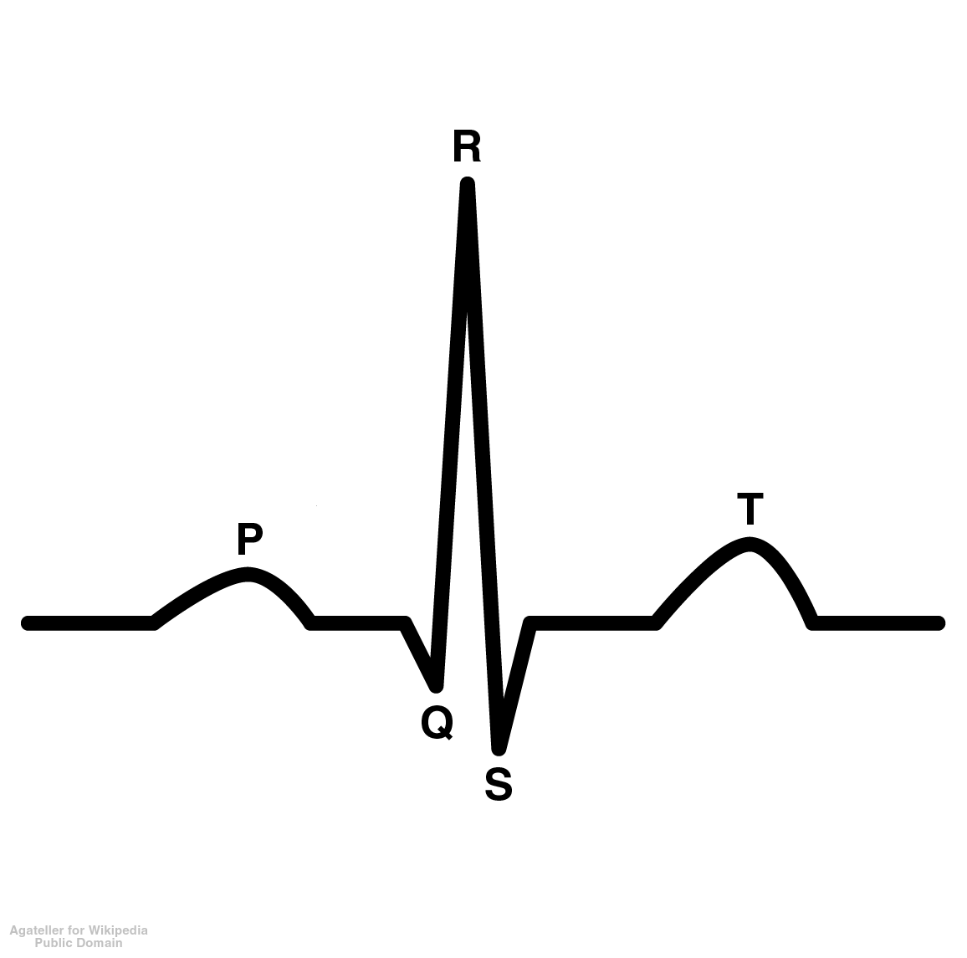

Important to note the size & timing of waves when reading an ECG

# P Wave = Atrial Depolarization

- spreads from the SA node through the atria

- 0.1s after the P wave begins, atria contracts

- repolarization of atria not evident because it is buried in the QRS complex

# QRS Wave = Ventricular Depolarization

- spread of electrical excitation through the vetricles

- shortly after QRS wave begins, the ventricles contract

# T Wave = Ventricular Repolarization

- occurs before the ventricles start to relax

- smaller & more spread out because repolarization takes longer

**Conducting Areas of the Heart:**

***P Wave:***

# SA: Node: Depolarization of the Atria

* Fires an electrical impulse (influencd by hormonal & neurological factors) through the atria
* Contraction of the Atria occurs
* blood forced into the vetricles
* The normal heart rate rhythm is called **normal sinus rhythm** because a collection of heart cells called the sinus node (SA) controls the rate and rhythm.
* Depolarizes: 70-80x/ min - Regular Individual

40 x/ min – Athletes

***QRS Waves:***

# AV Node: Depolarization of the Ventricles

* receives an impulse from the SA Node
* electrical signal continues down the specialized conducting system
* Depolarizes: 15 – 20 x/ min
* When the SA node is diseased, the AV node takes over
* If a person had a heart rate of only 40 bpm, they either were a high aerobic athlete or they need a pace maker

**Bundle of His:**

* a conducting system, located in the septum between the ventricles
* connects the AV Node to the Purkinje Fibers

**Purkinje Fibers:**

* branches from the bundle of His
* excitation is passed within the ventricle cells
* the Ventricle Contracts, blood is pumped out to the:

- systemic circulatory system via the aorta (O2 rich)

* pulmonary system via the pulmonary artery (O2 poor)

## T Wave

**Relaxation:**

* Repolarization of the ventricle muscles
* Cycle starts again

**Abnormal ECGs:**

# Large P Wave = Enlarged Atria

- problems with the bi or tricuspid valves causes a backup of blood in the atria resulting in the expansion of the atrial walls

# Enlarged Q Wave = Myocardial Infarction (HEART ATACK!!)

# Enlarged R wave = Enlarged Ventricles

# Flatter T Wave = The Heart receiving insufficient Oxygen

**Tachycardia =** a fast resting heart beat greater than 100bpm in adults

**Bradycardia =** a abnormally slow/ unsteady resting heart rate less 50 bpm

-

**Heart Sounds:**

**Lub = Sound of AV (Atrio-ventricular) valves closing (tri & bicuspid)**

* **contraction of the atrium with blood going into the ventricles**
* **a “ long & low” sound**

**Dub = Sound of Pulmonary & Aortic Valves closing**

* **contraction of the ventricles with blood going into the aorta/ pulmonary vien**
* **a “ short & sharp” sound**

**Regulation of Cardiac Output**

**Cardiac Output = Heart Rate x Stroke Volume**

**(Q) = bpm x (diastolic volume – systolic volume) ml**

**Factors Influencing Heart Rate:**

1. ⇓ HR = Parasympathetic Stimulation
2. ⇑ HR = Sympathetic Stimulation
3. ⇑ HR = ⇑ Plasma Epinephrine (Adrenal Medulla)

**Factors Influencing Stroke Volume:**

1. ⇓ Contractility = Parasympathetic Stimulation
2. ⇑ Contractility = Sympathetic Stimulation
3. ⇑ Contractility = ⇑ Plasma Epinephrine (Adrenal Medulla)
4. ⇑ Stroke Volume = ⇑ End Diastolic Volume

**Blood Pressure:**

**Blood pressure** refers to the force exerted by circulating blood on the walls of blood vessels

#### Systolic = The force your blood exerts when the heart is contracting

Diastolic The force your blood exerts when the heat is relaxing

Normally 120 mm Hg

80

Measured using a **sphygmanometer**

**Hypertension**

* + persistently elevated blood pressure
  + a major cause of heart failure, kidney failure, & stroke

Hypertension (mm Hg)

|  |  |  |  |  |  |
| --- | --- | --- | --- | --- | --- |
|  | Normal | Mild HT | Moderate HT | Severe HT | Very Severe HT |
| Systolic | 120 | 140-160 | 160-180 | 180-200 | 200+ |
| Diastolic | 80 | 90-100 | 100-110 | 120-130 | 130+ |

**Risk Factors:**

1. Sex – male
2. Race – Black
3. Lifestyle – smoker, diet, drinker